Kubernetes Task - 03

- Create a ClusterIP service for an Apache web server pod.

What is ClusterIP?
A Service in Kubernetes provides a stable network identity (IP/DNS) to access pods.
ClusterIP means:
- Service gets an internal IP
- Accessible only inside the cluster
- Used for pod-to-pod communication
Example:
- Frontend pod talks to backend pod
- Backend pod talks to database pod

Create a new file vi httpd.yml

apiVersion: v1
kind: Pod
metadata:
name: apache-pod
labels:
app: apache
spec:
containers:
- name: apache-container
image: httpd
ports:
- containerPort: 80
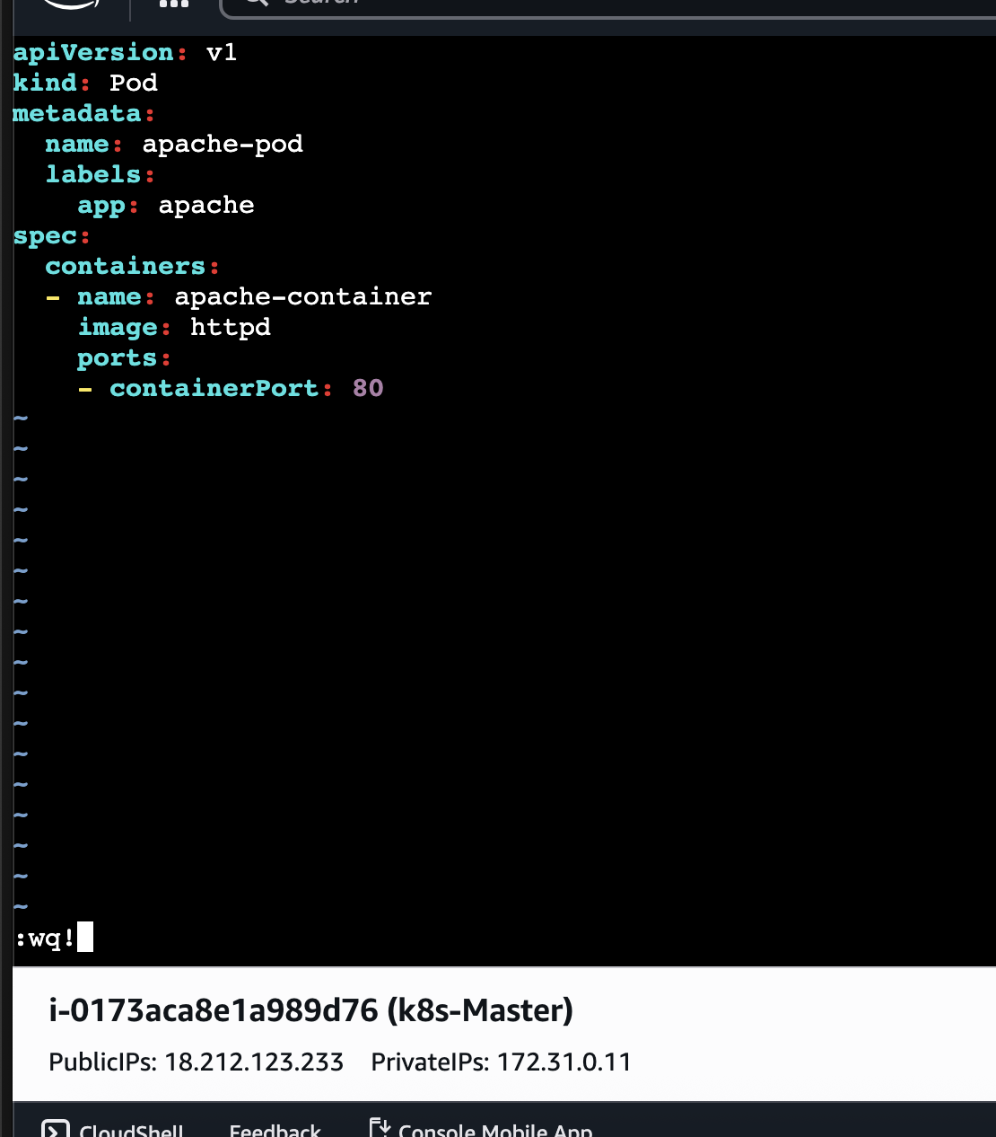

Apply ⇒ kubectl apply -f apache-pod.yaml
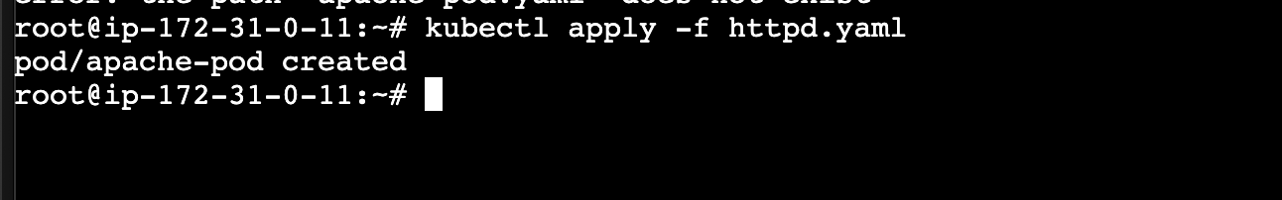
Check ⇒ kubectl get pods -o wide
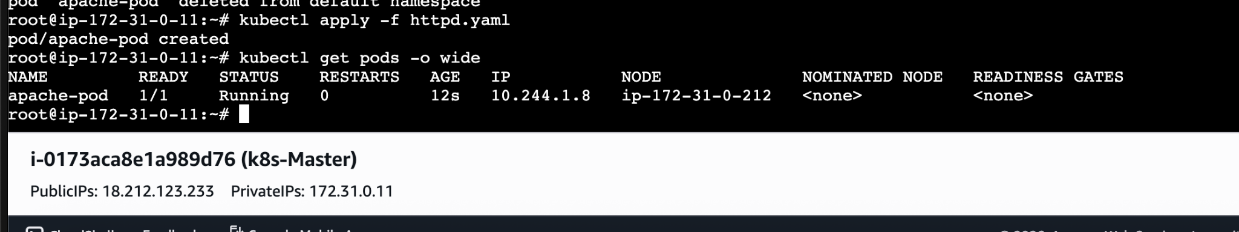

Now lets create a service file
Vi service.yaml
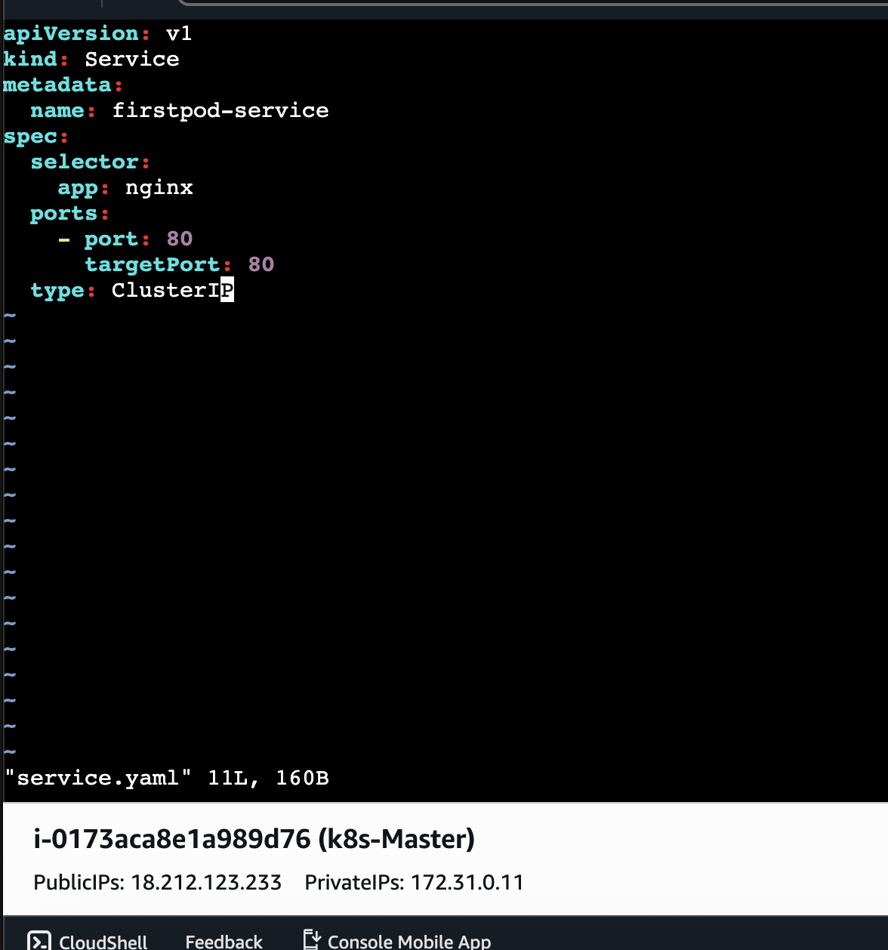
Verify ⇒kubectl get svc
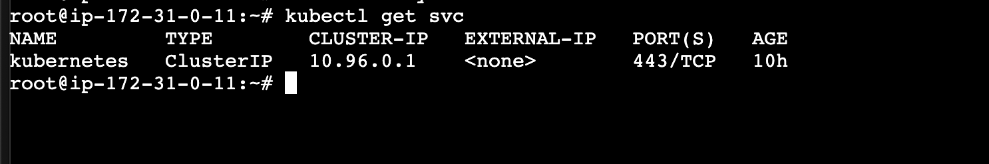

- Expose an Nginx pod externally using a NodePort service.

What is NodePort?
NodePort exposes services outside the cluster.
Traffic flow:
Browser → NodeIP:NodePort → Service → Pod
Default NodePort range:
30000–32767
Create ⇒ vi httpd.yaml

apiVersion: v1
kind: Pod
metadata:
name: nginx-pod
labels:
app: nginx
spec:
containers:
- name: nginx
image: nginx
ports:
- containerPort: 80
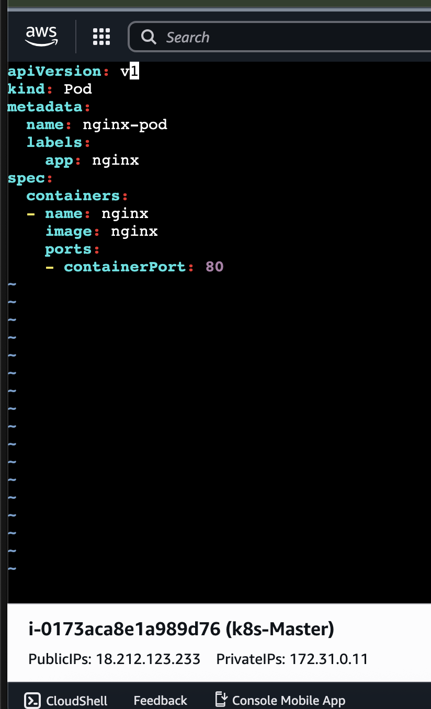
Apply ⇒ kubectl apply -f nginx-pod.yaml
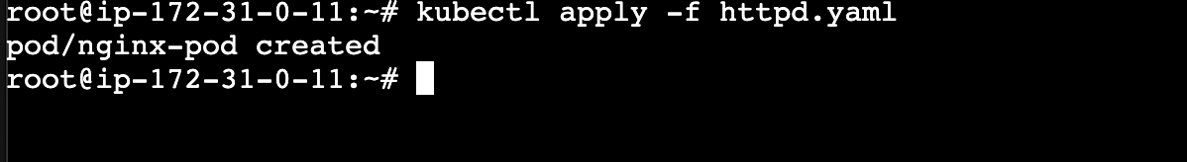
Lets create a service file now
Vi service.yaml
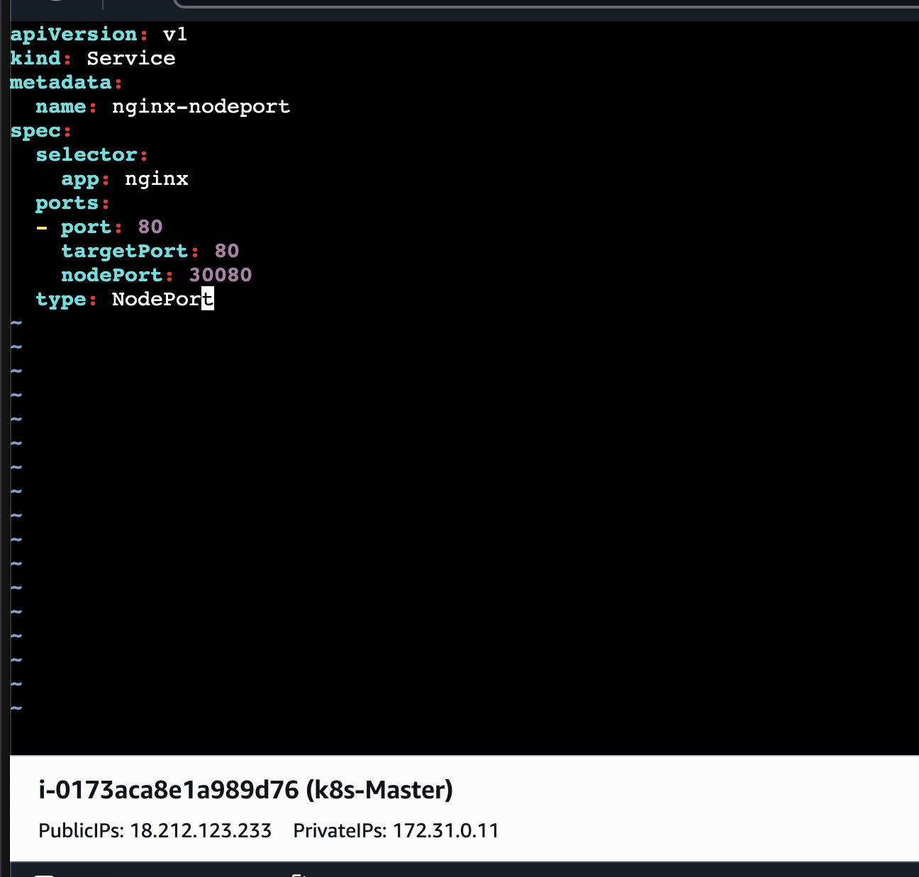
Apple & Verify ⇒ kubectl apply -f service.yaml & kubectl get svc
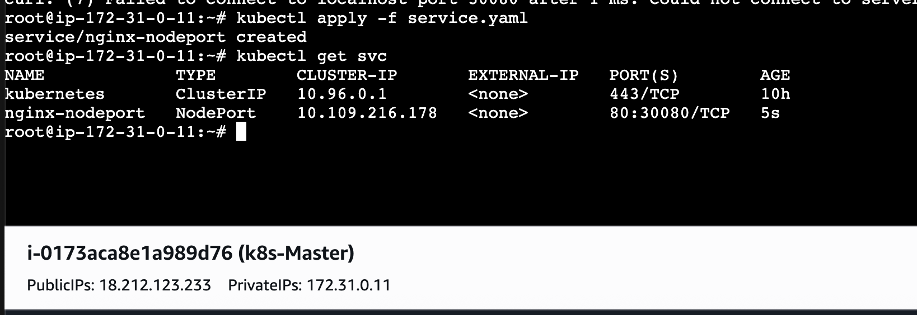
Verify in browser using the port 30080
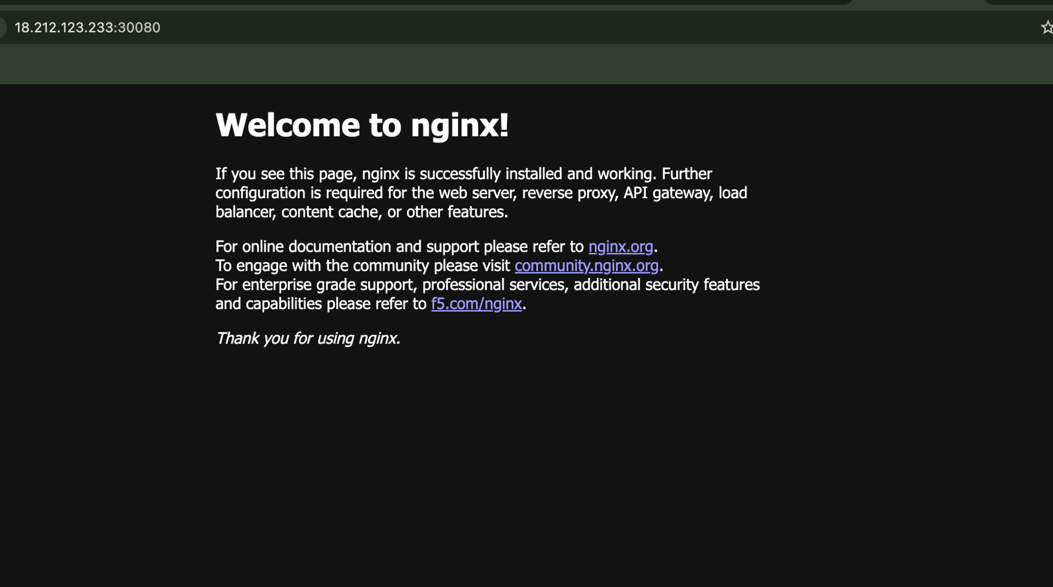

- Deploy a ReplicationController to maintain 3 replicas of an Nginx pod.

Why ReplicationController?
RC ensures the desired number of pod replicas always run.
Example:
Desired replicas = 3
If one pod crashes:
- RC detects only 2 running
- Creates new pod automatically
Create a new file vi rc.yaml
apiVersion: v1
kind: ReplicationController
metadata:
name: nginx-rc
spec:
replicas: 3
selector:
app: nginx
template:
metadata:
labels:
app: nginx
spec:
containers:
- name: nginx
image: nginx
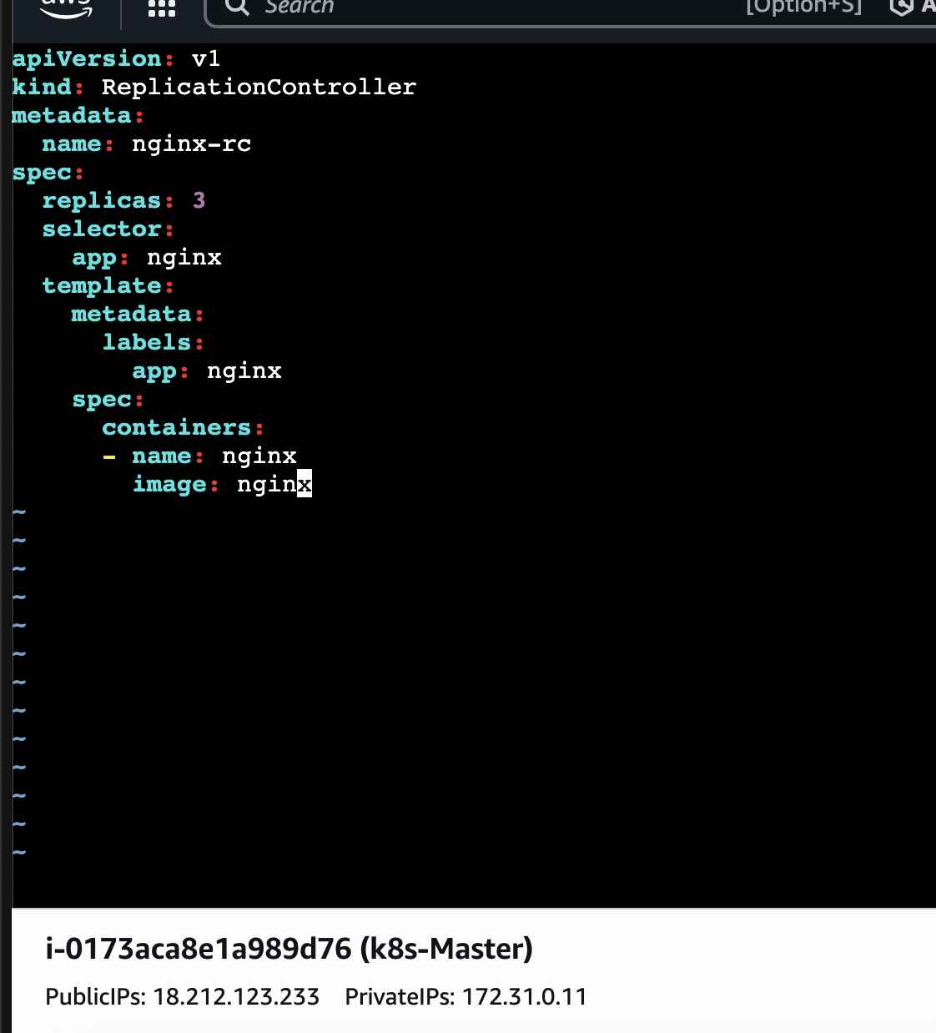
Apply ⇒ kubectl apply -f rc.yaml
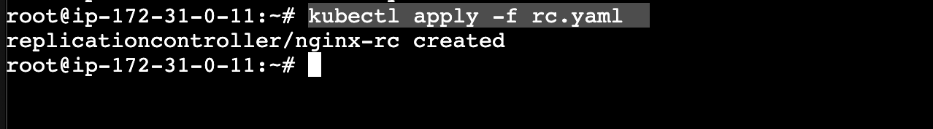
Verify ⇒ kubectl get pods
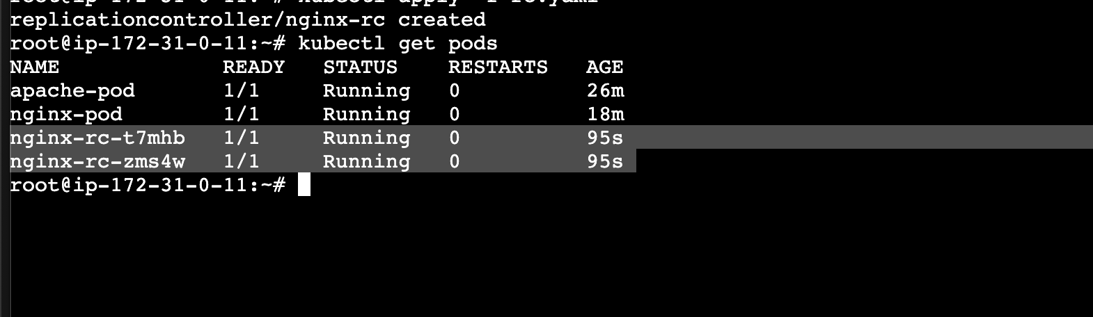

- Scale the ReplicationController from 3 replicas to 5 replicas.
For this used the above file and change the replicas from 3 ⇒ 5
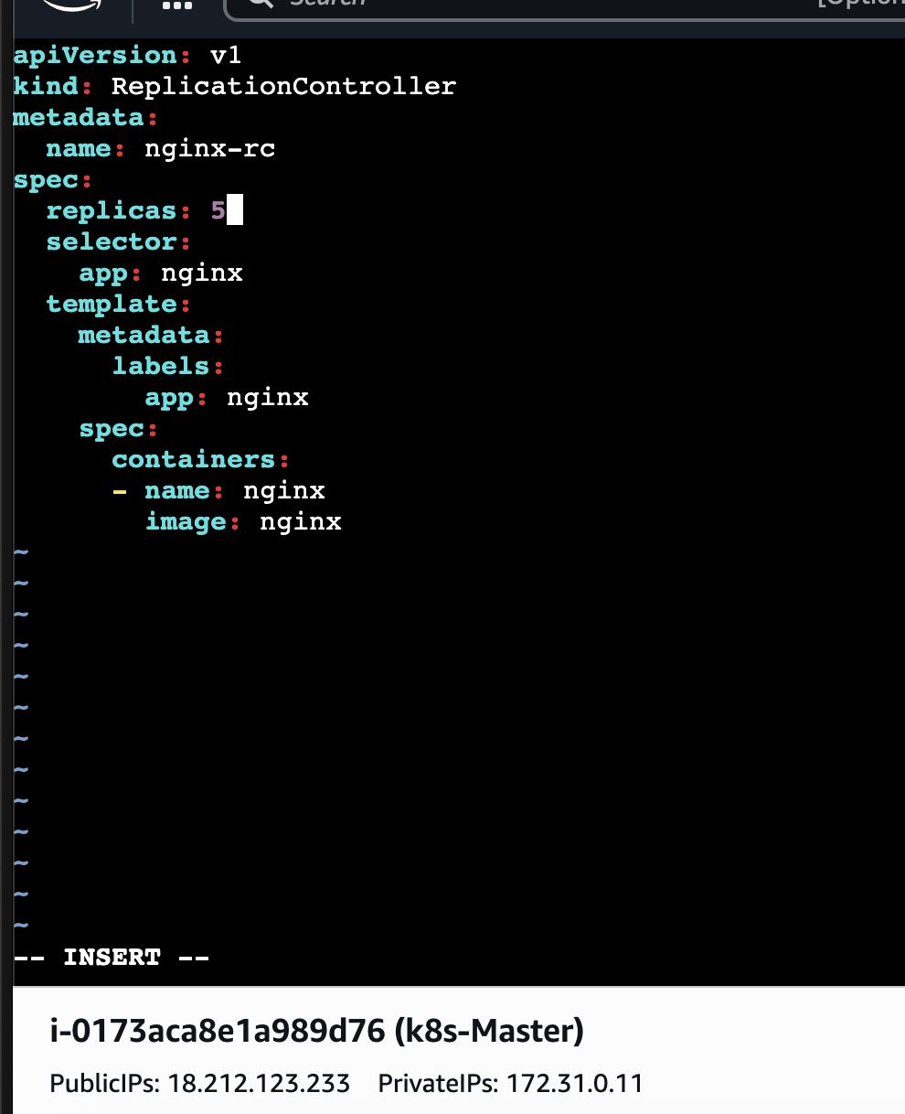

Apply ⇒ kubectl apply -f rc.yaml
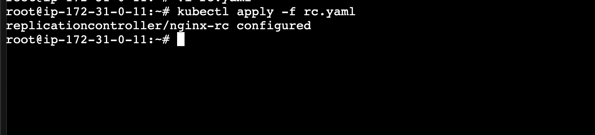

Verify ⇒ kubectl get pods
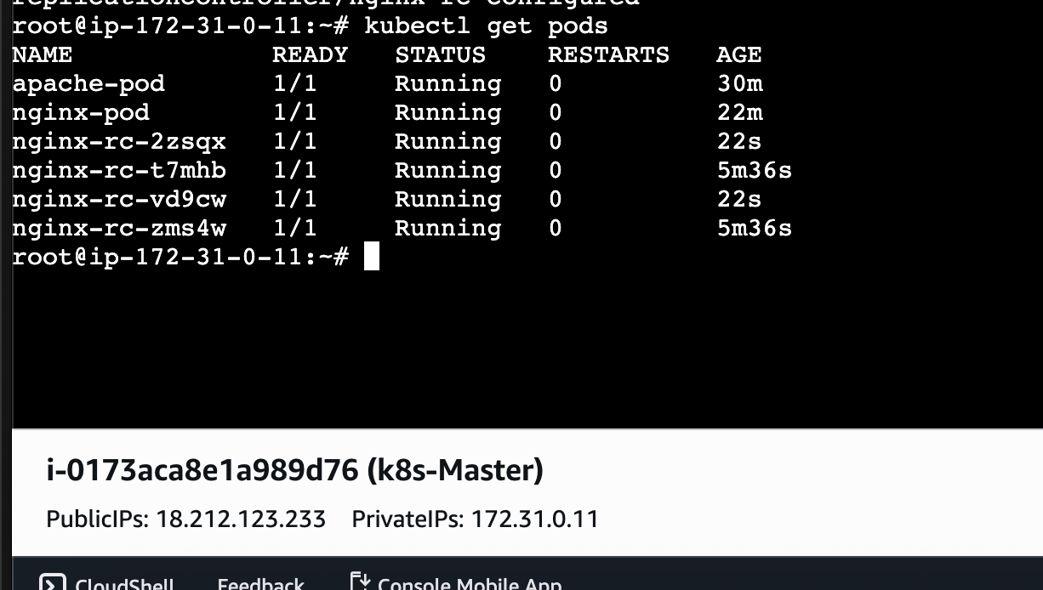

- Create a ReplicaSet to manage pods based on multiple labels (prod and test).

ReplicaSet is an improved version of RC.
Main improvement:
Supports set-based selectors.
Multiple Labels
Suppose we want pods matching BOTH:
env=prod
tier=test

Lets create a new file for rs.yaml
apiVersion: apps/v1
kind: ReplicaSet
metadata:
name: multi-label-rs
spec:
replicas: 3
selector:
matchLabels:
env: prod
tier: test
template:
metadata:
labels:
env: prod
tier: test
spec:
containers:
- name: nginx
image: nginx
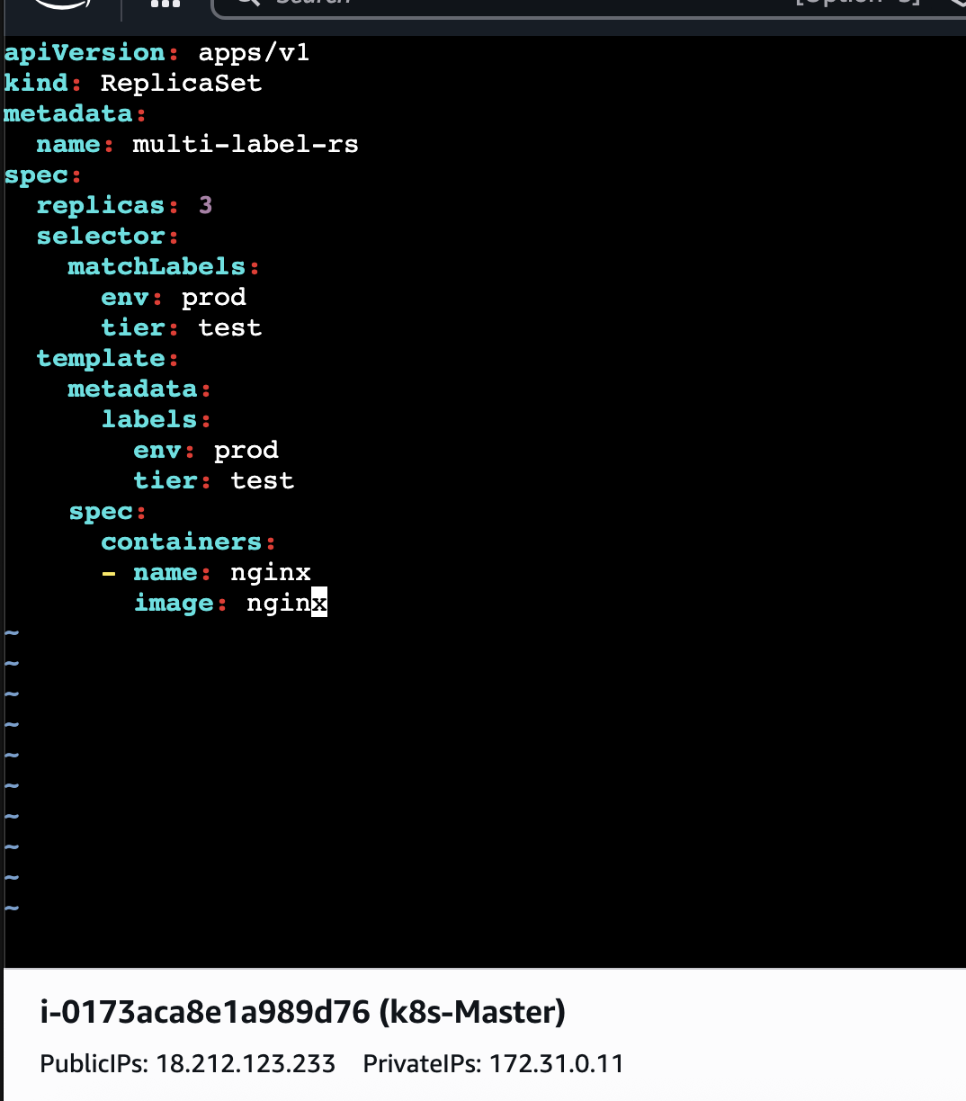

Apply ⇒ kubectl apply -f rs.yaml
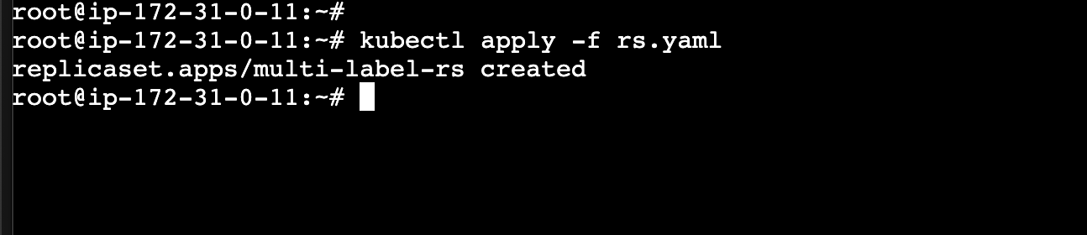
Verify ⇒ kubectl get pods
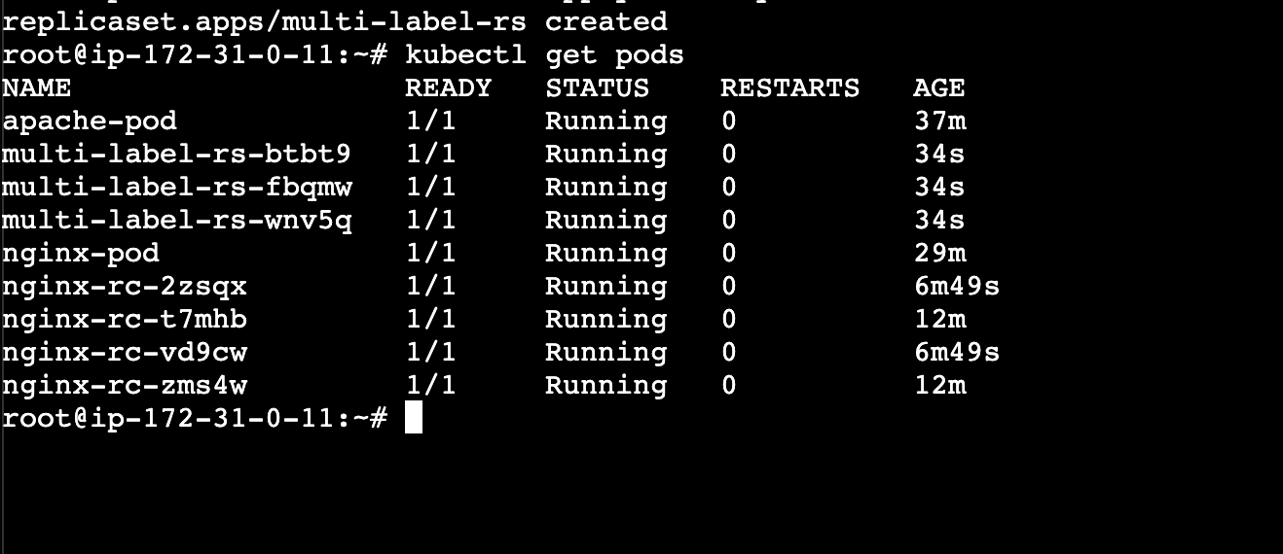
Verify the replica set ⇒ kubectl get rs
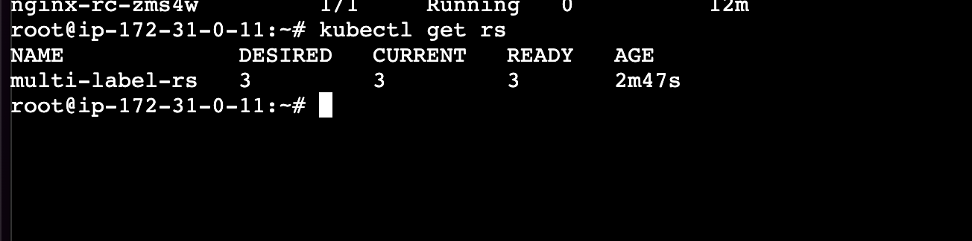
Verify the labels kubectl get pods –show-labels
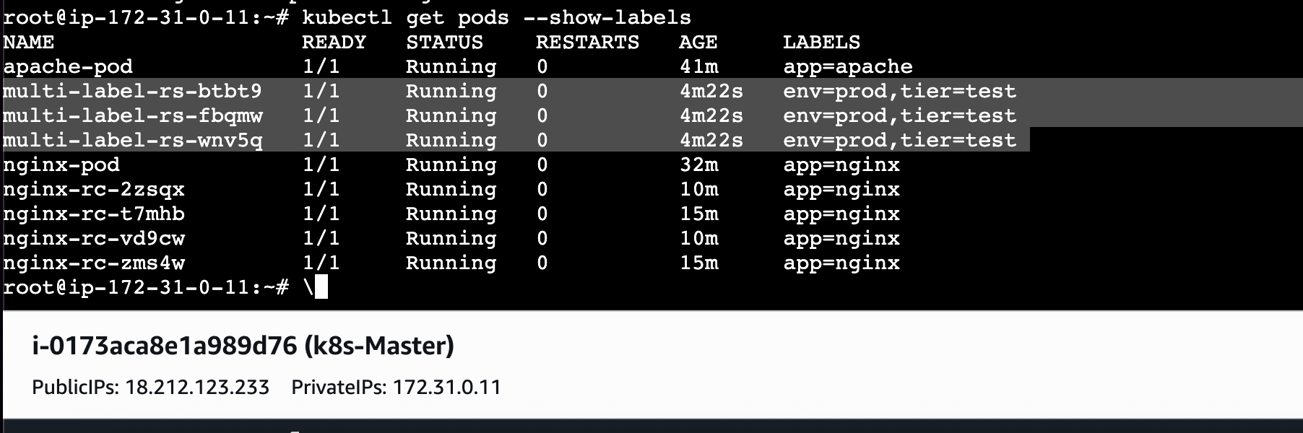
A ReplicaSet was successfully created using multiple label selectors. It maintained the
desired number of Pods and selected Pods where app=nginx and env was either prod or
test.

- Deploy a ReplicaSet that excludes pods with the label backend.
Create a new yaml file
apiVersion: apps/v1
kind: ReplicaSet
metadata:
name: exclude-backend-rs
spec:
replicas: 3
selector:
matchExpressions:
- key: tier
operator: NotIn
values:
- backend
template:
metadata:
labels:
tier: frontend
spec:
containers:
- name: nginx
image: nginx

Apply and verify the replica set ⇒ kubectl apply -f rs.yaml and kubectl get rs
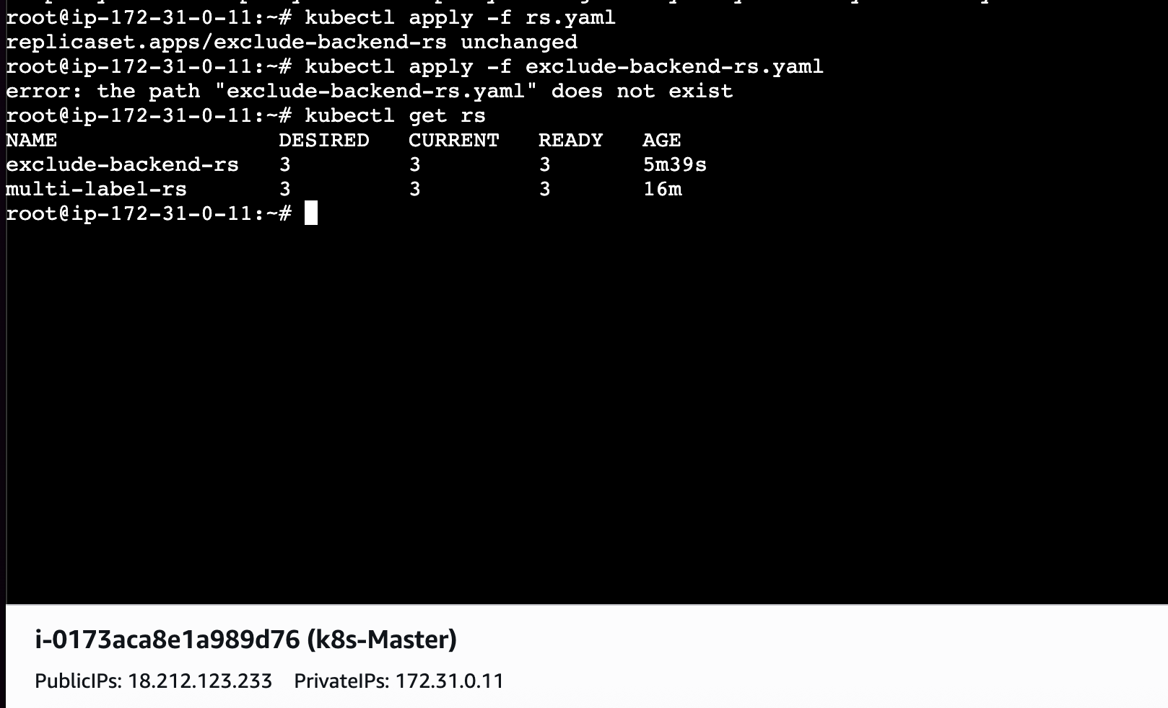

Check the pods and labels
kubectl get pods --show-labels
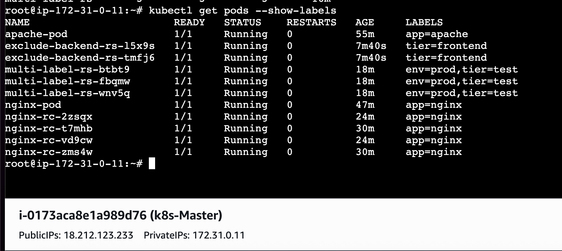

A ReplicaSet was successfully deployed with a selector that excludes Pods labeled
tier=backend. It manages only Pods whose tier label has a value other than backend.

- Test load balancing across multiple pods using a NodePort service.
Suppose 3 pods run the same app.
Without service:
Need to manually access each pod IP.
Problem:
- Pod IP changes
- Hard to manage
Service solves this.

Lets create a yaml file
apiVersion: apps/v1
kind: Deployment
metadata:
name: lb-deployment
spec:
replicas: 3
selector:
matchLabels:
app: lb-app
template:
metadata:
labels:
app: lb-app
spec:
containers:
- name: nginx
image: nginx
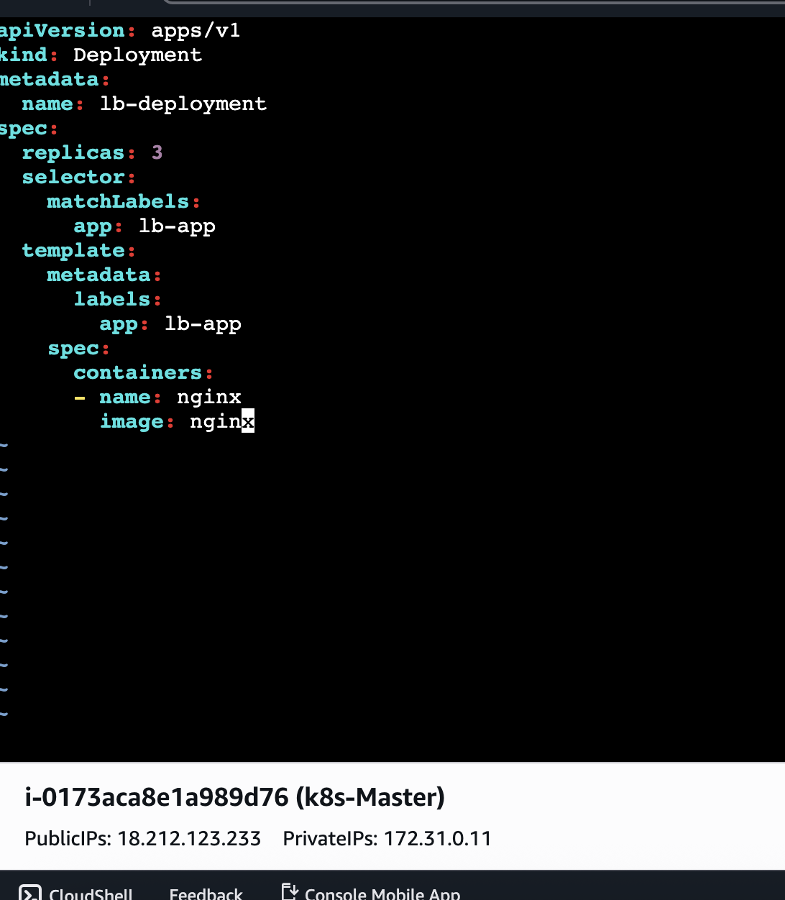

Apply ⇒ kubectl apply -f deploy.yaml

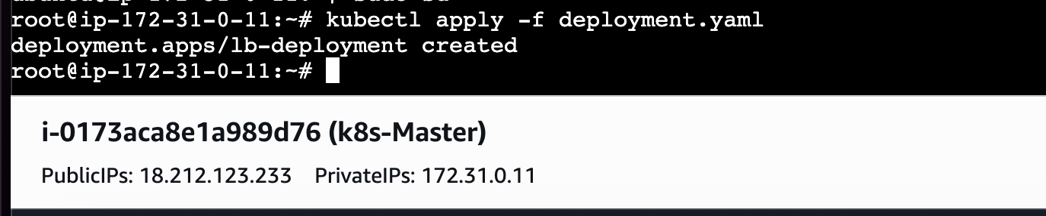
Lets Expose ⇒ kubectl expose deployment lb-deployment \
--type=NodePort \
--port=80
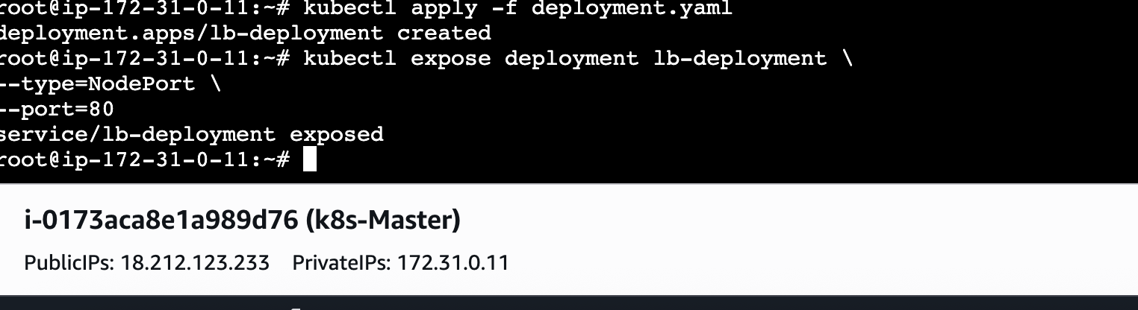

Load Balancing Concept
Service maintains endpoint list.
Example:
Pod1 → 10.244.0.2
Pod2 → 10.244.0.3
Pod3 → 10.244.0.4
Incoming requests distributed across pods.
Example:
Request 1 → Pod1
Request 2 → Pod2
Request 3 → Pod3
(roughly balanced)

Check Endpoints ⇒kubectl get endpoints
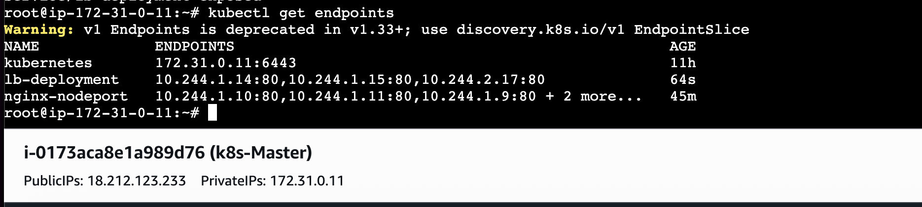

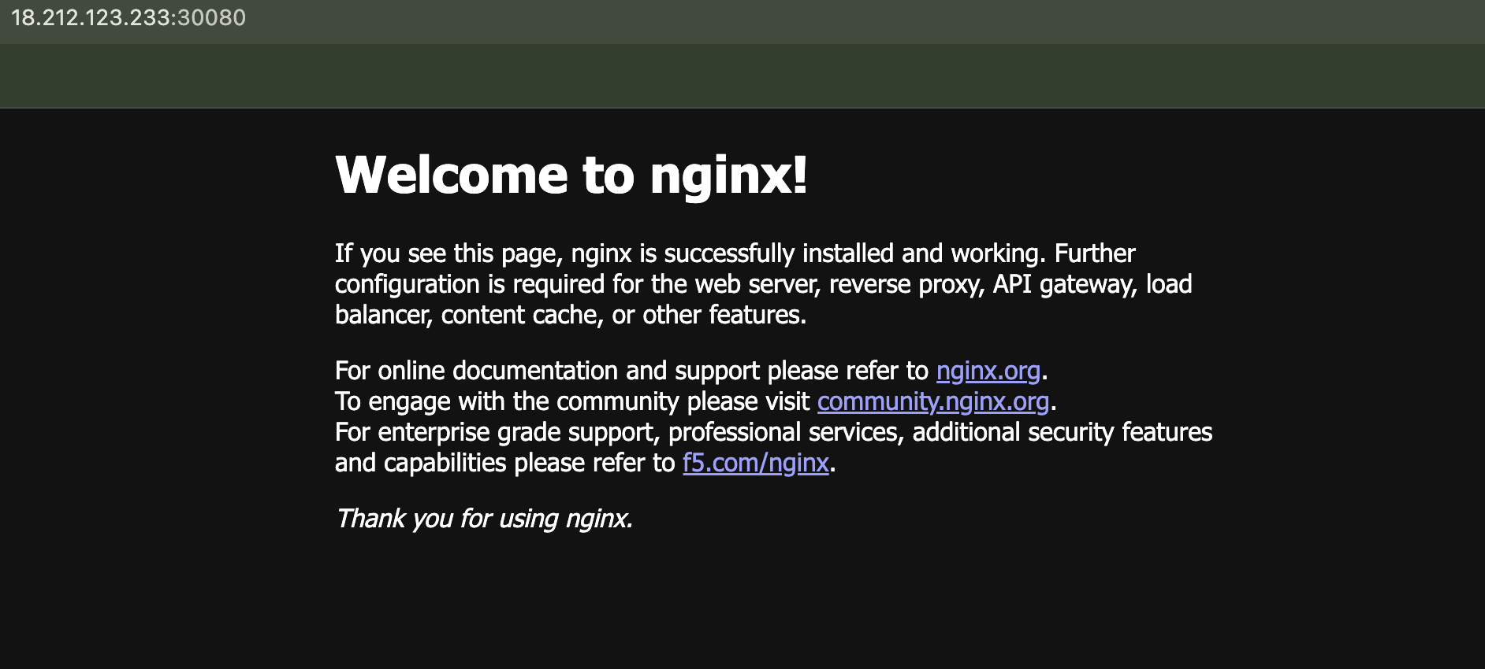

- Delete a ReplicationController without affecting the running pods.
Normally ⇒ kubectl delete rc nginx-rc
Deletes:
- RC
- Managed pods
But sometimes we want:
Delete RC only
Keep pods running

By using ⇒ kubectl delete rc nginx-rc --cascade=orphan
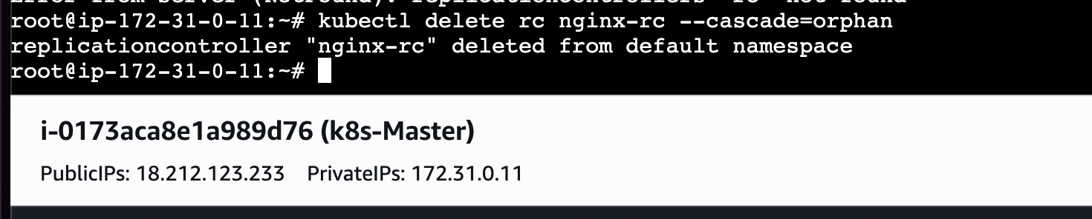

What is Orphan?
Orphan means ⇒Pods lose parent controller but continue running.
Before deletion ⇒RC owns 3 pods
After deletion ⇒No RC
3 pods still alive
Useful when migrating from:
- RC → ReplicaSet
- RC → Deployment
Lets verify if we have any rc available
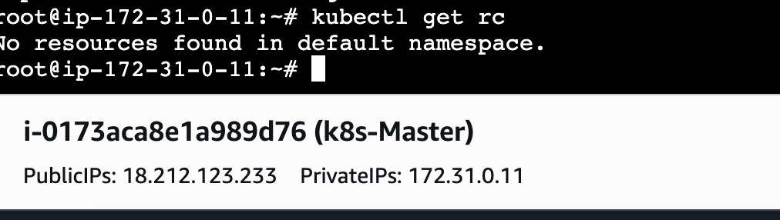
Now lets check pods
Kubectl get pods
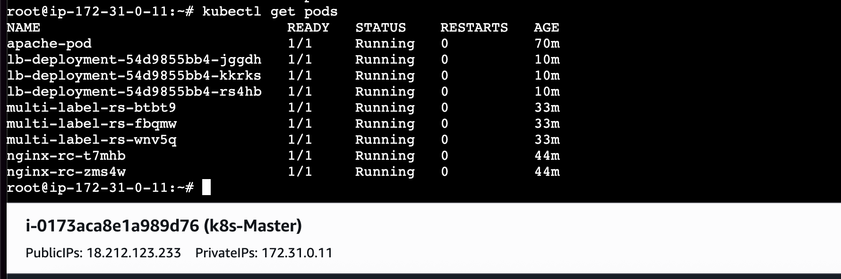

The ReplicationController was successfully deleted using --cascade=orphan. The
controller was removed, while the running Pods continued to run independently because
they are no longer managed by any ReplicationController.

